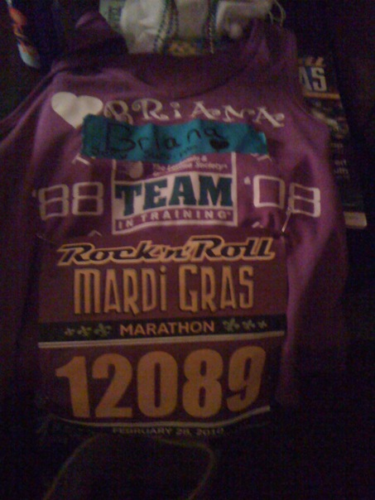
Team in Training and the Leukemia & Lymphoma Society invite you to:
Blues and Burgers at the Batesville Store
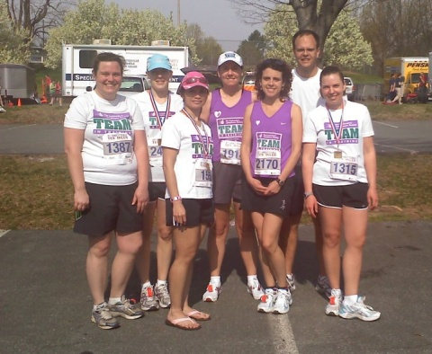
6-9:30 Thursday June 24th
Batesville Store Batesville VA
http://www.thebatesvillestore.com/
Blues Jams by Eli Cook
Burgers, BBQ goodies, and full menu available

For the Kids:
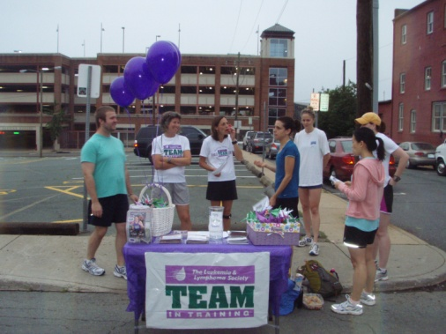
Face Painting
Paper Crane Origami

Proceeds from this event will be donated to the Leukemia and Lymphoma Society.

